**Hello**

**I’m Radhika**

**Computer Science Engineer**

**About Me**

I’m Radhika Sharma, a final-year B. Tech student specializing in Artificial Intelligence and Machine Learning at The NorthCap University, Gurugram. I am passionate about programming, AI, and robotics and aspire to build intelligent systems that make a positive impact.

My hobbies include space exploration, environment conservation, gardening, and traveling, which inspire my creativity and problem-solving skills.

I’ve gained hands-on experience through internships with the India Meteorological Department (IMD) Delhi, Oasis Infobyte, and My Social Fox, where I worked on building AI models, NLP systems, and data analysis tools.

**Experience**

* India Meteorological Department, Delhi

Research Intern

* Oasis Infobyte

Data Science Intern

* My Social Fox

Data Science Intern

**Achievements**

**Microsoft Certified: Azure Fundamentals**

Microsoft-2024

**Introduction to Machine Learning**

Internshala-2023

**Google Analytics Certification**

Google-2023

**Ethical Hacking Essentials**

EC-Council-2023

**Database Foundations**

Oracle Academy -2023

**Networking Essentials**

CISCO-2023

**Data Structures: C++**

OIS-2022

**Integrated Course: C and C++**

OIS-2022

**Skills**

**Languages**: Python, C++, Java, SQL

**Frameworks & Libraries**: NumPy, Pandas, SciPy, Tkinter, Scikit-learn, LangChain

**Platforms**: Windows, Linux

**Database**: MySQL

**Tools**: Eclipse, Servlet

**Selected Works**

**Arduino Rover**

**Computer Vision based image quality assessment, object recognition and NLP based tagging**

Developed and implemented advanced computer vision techniques to enhance image quality assessment, improving the accuracy and reliability of meteorological image analysis. My work included object detection and pattern recognition to identify weather-related elements in images, even those not visible. I utilized image processing techniques like sharpening and restoration to improve clarity, executed image retrieval for comparative research, and analysed patterns to better understand weather phenomena.

**Sales Price Prediction**

**Email Spam Detection**

**Multiple Disease Prediction**

**Image Denoising**

**About My Internships**

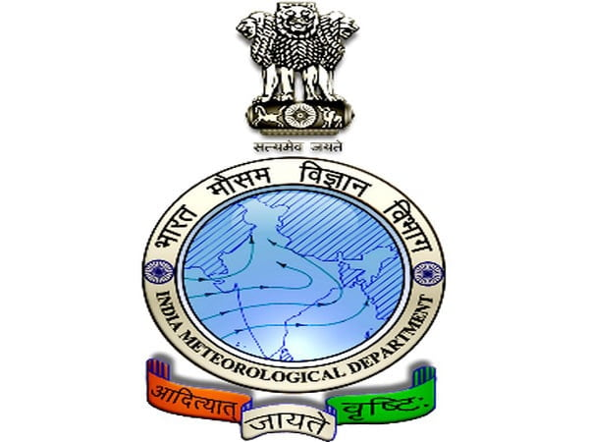

**India Meteorological Department, Delhi**

Developed advanced computer vision techniques, focused on image quality assessment, object detection, and image retrieval to enhance meteorological data analysis and visualization.

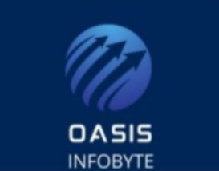

**Oasis Infobyte**

Designed an email spam detection system to enhance communication security and assisted businesses in optimizing pricing strategies through sales price prediction.

**My Social Fox**

Created accurate ML models for iris classification and car price prediction, conducted an in-depth analysis of unemployment trends using statistical methods, and developed a reliable car price prediction model to support informed decision-making.

**Get In Touch**

Let’s connect and share a passion for innovation and creativity. If you'd like to discuss a project and share ideas, feel free to reach out!